1. Elaborate on the differences between test cases and test plans with
relevant examples.
A test cases can be defined as a set of descriptions, steps, conditions, expected result, actual results and remarks which are done to verify special features or function of a specific application, website or a device works correctly.
It is a step by step execution process to ensures that the function or feature works correctly. It is very detailed oriented process as it focused in a feature or a scenario. Example: For a login page using correct username and password.
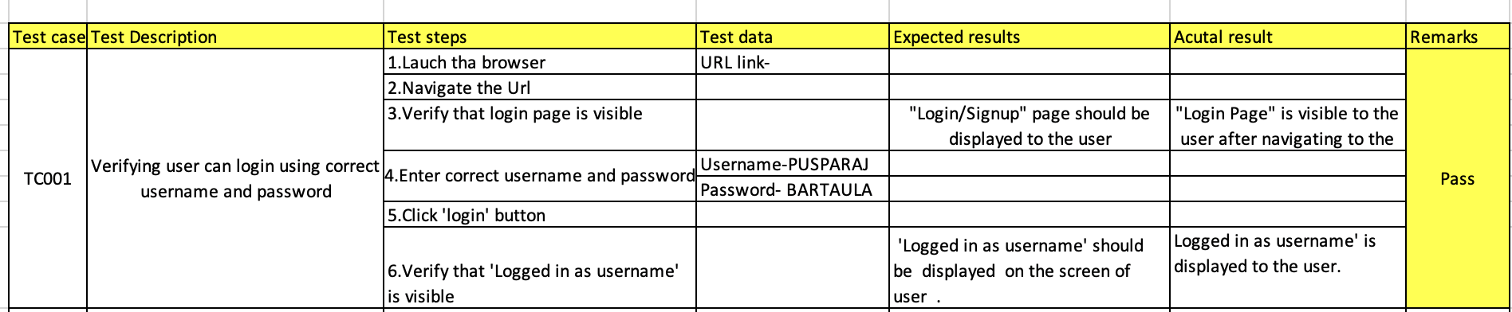
A test plan is a documented process which shows “how a test can be done”. What to test, test approach, test environment, resource allocation, risks, schedule and timeline are the components of the test plan. It is very strategic process as it is the roadmap of the entire testing process.
Example: For a login page
1. Test plan ID - TP001-Login
2.Introduction
This test plan shows the strategy, scope, objectives, resources, and schedule for testing the login page of a
website. The goal is to make use that, we are able to login with correct username and password whereas if
we use the wrong username or password or both then invalid credentials should be pop up.

3. Objective
a) Verify that user can login with valid username and password
b) Verify that ‘invalid credentials’ is displayed on the screen when they use invalid username /password or
both
c) Verify that ‘Logged in as username' is displayed to the user” after they click on the signup.

4. Scope
a) Valid login
b) ‘Invalid credentials’ shows when use invalid username /password

5. Test Environment
- Browser: Chrome, Brave, Firefox
- OS: MacOs, windows 11, windows 10
- URL –

6.Resouces
- Junior QA- 1

7. Test type
- Functional Testing- functional testing will be used to ensure that login function is working correctly.

3. Prepare a test plan for the above headphone produced.
1.Test plan ID - TP001-Login

2.Project: Headphone with Detachable Microphone

3.Introduction- This test plan shows, scope, objectives, resources, and schedule for testing of the newely produced Headphone with attachable microphone. The goal is to make sure that product meets the functional, performance, usability, and reliability requirements before release.

4.Objective
- Verify the build quality of headphone and the microphone.
- Verify the functions of detachable microphone.
- Verify all the buttons (power on/off, mic on/off and volume up/down) function.
- Identify any defects on the headphone and microphone.
- To test the compatibility with different devices.
- Verify audio and sound quality.
- Verify charging and battery health behavior

5. Scope
- Physical damages
- Audio output testing
- Microphone functionality
- Durability and comfort
- Charging, battery drainage, and indicator behavior

6. Features to be tested
- Audio output of the Left and right channel of the headphone
- Maximum and minimum volume handling
- Microphone detection
- Mic on/off switch
- Power on/off switch
- Durability of all the buttons
- Charging behavior
- Heating issues
- Build quality and compatibility

7. Test Strategy-
- Functional testing and performance testing will be used to test all the user facing features and to check the maximum load of speaker, audio recorder and battery performance

8. Test environment
- Headphone with attachable microphone
- Charger with different power output (5w and 10w)
- Smartphones and Computers (Android/IOS/windows/MACos))
- Audio recording and audio playing applications

9.Resources
- Junior QA-1

10. Test timeline
Test phases | Start date | End date
Requirement analysis | 2025-11-11 | 2025-11-12
Test environment setup and execution | 2025-11-13 | 2025-11-14
Defect reporting, fixation and regression testing | 2025-11-15 | 2025-11-18
Final testing and sign-off | 2025-11-19 | 2025-11-20

11.Entery Criteria
- All the components and tools are available for testing
- Test cases prepared and reviewed

12. Exit Criteria
- All test cases has been executed
- Major defect has been fixed

13.Risks
- Battery may not take charge if locally made/ cheap quality charger is used
- Heating issue may occur if high voltage charger is used

14. Mitigation
- Use certified charger only

4.Explain the difference between bug and issue by explaining bug cycle steps.
Bug can be defined as the flaw in the software, application or a website that doesnot work as expected or as the expectations of user
A button that doesnot work while clicking , application crashes when we refresh it are some of the example of bugs

Issue can be define as a flaw, error , defect or even a bug can be consider as a issue. It is a boarded and vast term.
Error on a code, a bug found on an application can be consider as some of the example of issue.
Bug life cycle

Bug life cycle describes the journey of the bug from the moment it was found or born to its death.

Step-by-Step Breakdown of the bug lifecycle (This cycle helps to show why the bug is different from a issue):

- New – A tester finds a unusual behavior (a bug is born) and then report it with evidences like screenshot or a recording, step to replicate etc.
- Assigned – The team lead conforms the bugs and then assigned it to developer to fix it.
- Open/ In progress- Now the developer checks the bug and make a move towards analyzing and fixing.
- Fixed/Resolved – The developer fix the bug, check locally and then send it to tester(QA) to recheck it.
- Retest – Tester will test it in exact same scenario to make sure that bug is fixed.
- Verified – Tester confirms that bug is fixed.
- Closed – Bug is officially closed (death of a bug).

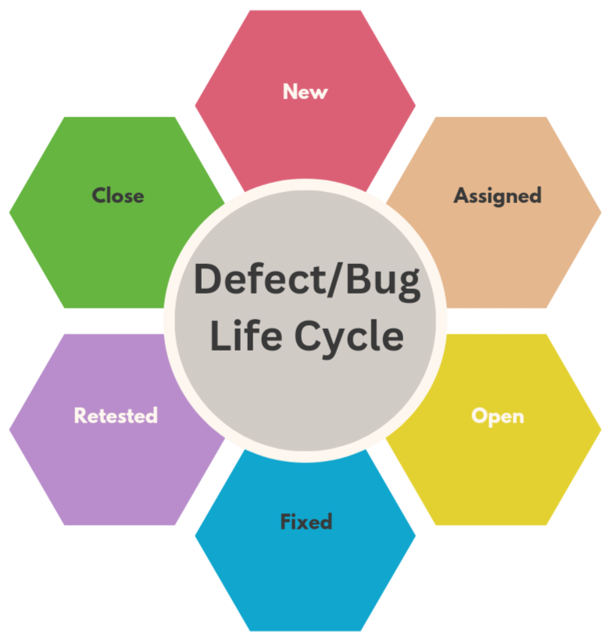
5. Prepare a bug report for the failed cases of the headphones.

Bug report

Bug ID: BG-001

Title: Headphone over heats while charging

Priority: LOW (low, medium, normal, high, critical and Urgent)

Severity: NORMAL (low, medium, normal, high, critical and Urgent)

Assignee: Elon Musk

Type: Non-functional
Label: Performance Testing
Environment: Original one (10V) model, (Normal)

Description: When the device is connected with the original charger, after an hour it start to over heat
Steps to replicate:
- Connect the headphone with the original charger.
- Allow the device to charge for 40-50 mins
- Check the outer casing of the headphone
- Sudden increase in temperature

Evidence:

6. Explain briefly about UI/UX Tests and prepare a Checklist for UI/UX Testing.

UI testing: User interface testing is more focused on visual representation like color, font size, button size, forms and layout. It is the interactive component.

UX testing: User Experience testing is about how the users interact with product, satisfaction and ease of use. Its goal is to provide smooth interaction to the user.
UI/UX testing ensures that the user find it appealing, easy and efficient to use.

UI/UX testing checklist

- Colors and fonts match everywhere
- Text is easily readable.
- All buttons work
- Link redirect to the correct pages.
- Works on different web browsers.
- Correct image sizes
- Not too confusing
- Keyboard navigation is supported.
- Responsiveness is verified on multiple devices
- No broken links or missing content
- Loading speed and smoothness
- Touch gestures work properly on mobile/Screentouch devices.

7.If you encounter a technology or tool you're not familiar with during an internship project, how would you go about learning it?
If I encounter a technology or tool that I am not familiar with, I try to learn it in a step and step way. For example I have learned selenium and have gained little experience by using it on a simple login page websites project, but INTUJI uses cypress for that at first I will understand how cypress and selenium are different from each other , learn and read about it on the internet to know about its basic and key features , watch some tutorial videos on youtube which will help me to understand it more quickly and easily and then try to work on simple basic projects using it. If I stuck or need any clarifications then I will ask my mentor which will surely help me to understand it more easily and will help me to gain hand on experience more quickly.
8. You can provide your personal experience here that motivates you for this work, which is why you selected QA for the internship.

It wasn't until my 1st year of college that I learned about Quality Assurance (QA). I became interested in learning more about this subject because one of my classmates worked in it. I began looking up QA online and discovered its main duties, such identifying bugs and making sure a product functions smoothely before launch. This drew my interest since it matches with my nature which is appriciating good work but also like identifying problems and improving things. To explore this further, I took a QA course at Techaxis, where I learned the testing process and tools like Selenium, which help identify bugs and problems more efficiently. Learning these practical skills made me even more interested in QA and motivated me to pursue it as an internship.

